10.61: The tension in the rope must be 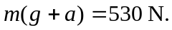 The angular acceleration of the cylinder is 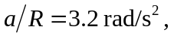 and so the net torque on the cylinder must be 9.28 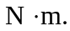 Thus, the torque supplied by the crank is and the force applied to the crank handle is 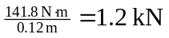 to two figures.

